WORKSHEET 1
- What is a dataframe?

A data frame is a table or a two-dimensional array-like structure in which each column contains values of one variable and each row contains one set of values from each column.

- Mention some characteristics of a data frame.

The Characteristics of a data frame are
- The column names should be non-empty.
- The row names should be unique.
- The data stored in a data frame can be of numeric, factor or character type.
- Each column should contain same number of data items.

- How would you extract the subsets of all MQ students from the data frame in task 2?

details = read.csv("Studentdetails1.csv")
MqStudent=subset(details,SEATCATG==”MQ”)
MqStudent

KUMARAGURU COLLEGE OF TECHNOLOGY
LABORATORY MANUAL

Experiment Number: 3
Lab Code : U18MAI4201
Lab : Probability and Statistics
Course / Branch : B.E-CSE,ISE, B.Tech-IT
Title of the Experiment : Applications of Correlation and Regression
STEP 1: INTRODUCTION
OBJECTIVES OF THE EXPERIMENT
- To construct the scatter plot and to visualize the relationship between two quantitative variables.
- To find the correlation between two variables in a data set.
- To find the coefficient of rank correlation between two variables in a data set by Spearman’s method.
- To determine the equations of the regression lines for variables and to predict the value of one variable when the value of the other variable is given.
- To construct the regression plot for the given variables.
STEP 2: ACQUISITION
Procedure for doing the Experiment:
1.  2.  3.  4.  5.  6. | To construct the scatter plot with the variables x and y  x=c(a,b,....)  y=c(l,m,....)  plot(x,y, xlab = “....”,ylab=”…”,xlim=c(0,10),ylim=c(0,25),col=c(“…”),main=”…..”)  To find the correlation between x and y  x=c(a,b,....)  y=c(l,m,....)  r=cor(x,y)  r  To find the Spearman’s rank correlation coefficient between x and y  x=c(a,b,....)  y=c(l,m,....)  r=cor(x,y,method=”spearman”)  r  To find regression line of y on x  regyx=lm(y~x) #lm stands for linear model  regyx  To find regression line of x on y  regxy=lm(x~y)  regxy  To construct the regression plot of y on x  plot(x,y)  abline(lm(y ~ x),col="---")
Note:
- plot(y~x) --- creates a scatterplot of y versus x
- regmodel = lm(y~x) --- fit a regression model
- abline(lm(y~x)) --- adds regression line to plot

Example
Construct the scatter plot and also find the coefficient of correlation and Spearman’s correlation coefficient between the ends per inch(X) and picks per inch (Y). Also find the two regression lines. Estimate the value of y when x = 26.
x 23 27 28 28 29 30 31 33 35 36
y 18 20 22 27 21 29 27 29 28 29
Solution:
R code:
x=c(23,27,28,28,29,30,31,33,35,36)
y=c(18,20,22,27,21,29,27,29,28,29)
plot(x,y,xlab ="X -axis",ylab ="Y-axis",xlim=c(0,50),ylim=c(0,40),col=c("green"),main="Introduction atoScatterPlot")
r=cor(x,y)
r
rank=cor(x,y,method="spearman")
rank

Scatter Plot:
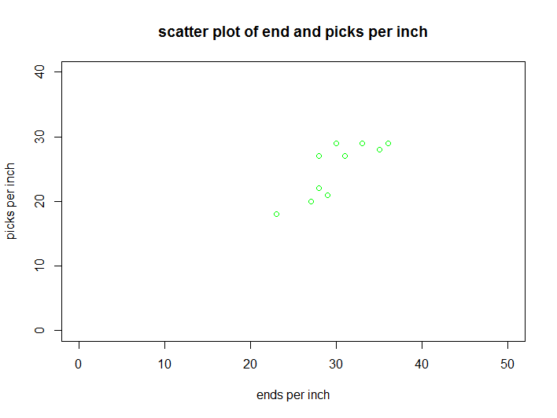
Output:
Correlation Coefficient = 0.8176052
Spearman correlation coefficient= 0.9955947

Conclusion:
There is strong positive correlation between ends per inch(X) and picks per inch(Y).

To find the regression line of y on x
regyx=lm(y~x)
regyx
Output
Call:
lm(formula = y ~ x)

Coefficients:
(Intercept) x
-1.7391 0.8913
ie, regression line of y on x is y= -1.7391+0.8913x
To find the regression line of x on y:
regxy=lm(x~y)
regxy
Output:
Call:
lm(formula = x ~ y)

Coefficients:
(Intercept) y
11.25 0.75
ie, regression line of x on y is 11.25+0.75y
To find y when x=26
y1= - 1.7391+0.8913*26
y1
[1] 21.4347
Regression plot of y on x
R Code:
plot(x,y)
abline(lm(y ~ x),col="dark green")
Plot:
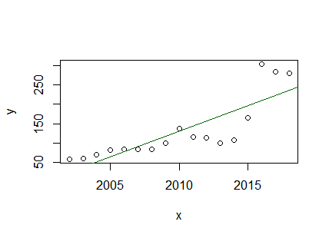

Task 1
Calculate the coefficient of correlation from the following figures relating to the consumption of fertilizer and the output of food grains in a district X:
Chemical fertilizer used (in metric tonnes):100,110,120,130,140,150,160,170,180,190,200,210,220,230
Output of food(in metric tonnes):
1000,1050,1080,1150,1200,1220,1300,1360,1420,1500,1600,1650,1650,1650
Also draw the scatter plot diagram for the above data and justify the result.

Solution:
R-Code:
x=c(100,110,120,130,140,150,160,170,180,190,200,210,220,230)
y=c(1000,1050,1080,1150,1200,1220,1300,1360,1420,1500,1600,1650,1650,1650)
plot(x,y,xlab="ChemFertilizer",ylab="Food",xlim=c(0,200),ylim=c(0,2000),col=c("red"),main="Scatter Plot")
r=cor(x,y)
r

Output:

>r
[1] 0.991053

Scatter Plot
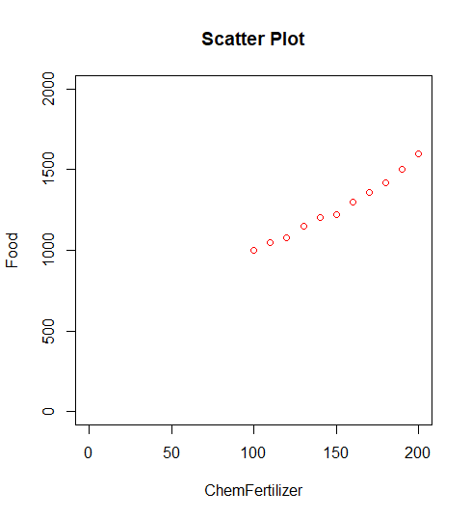
Task 2
Below are given the simple index numbers for the price of USB sound card for a number of years. Determine the scatter plot and correlation coefficient for the trend.
Year:2002,2003,2004,2005,2006,2007,2008,2009,2010,2011,2012,2013,2014,2015,2016,2017,2018
I.N:59,59.6,70,82.5,83.4,83.4,83.4,100,138.4,115.6,114.3,99.7,108.3,165,303.7,285.1,280.8

R-CODE:
x=c(2002,2003,2004,2005,2006,2007,2008,2009,2010,2011,2012,2013,2014,2015,2016,2017,2018)
y=c(59,59.6,70,82.5,83.4,83.4,83.4,100,138.4,115.6,114.3,99.7,108.3,165,303.7,285.1,280.8)
plot(x,y,xlab="Year",ylab="I.N",xlim=c(2000,2020),ylim=c(0,400),col=c("red"),main="Scatter Plot")
r=cor(x,y)
r
Output:
>r
[1] 0.8306042
Scatter Plot:
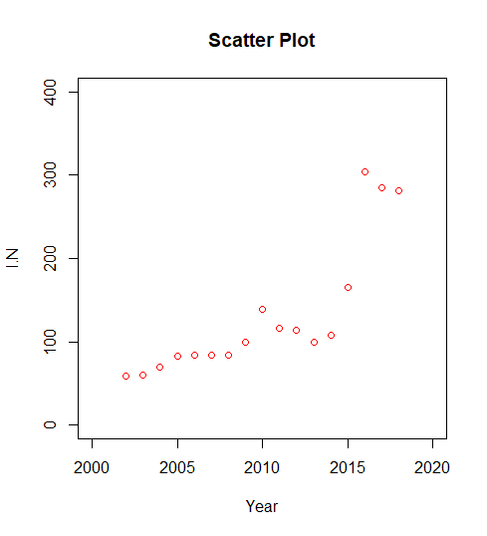
Task 3
Fifteen dishes in a cooking competition are ranked by 3 judges A, B, C in the following order.
A: 14,15,1,6,5,3,10,2,4,9,7,8,12,13,11
B:15,13,11,3,5,8,4,7,10,2,1,6,9,12,14
C:12,11,6,4,9,8,1,2,3,10,5,7,15,14,13
Find which pair of judges have the nearest approach to common taste in food.
Solution:
R-CODE:
x=c(14,15,1,6,5,3,10,2,4,9,7,8,12,13,11)
y=c(15,13,11,3,5,8,4,7,10,2,1,6,9,12,14)
z=c(12,11,6,4,9,8,1,2,3,10,5,7,15,14,13)
rankAB=cor(x,y,method="spearman")
rankBC=cor(y,z,method="spearman")
rankAC=cor(x,z,method="spearman")
rankAB
rankBC
rankAC

Output:
>rankAB
[1] 0.3857143
>rankBC
[1] 0.5357143
>rankAC
[1] 0.6571429
Conclusion:
Judges A and C have the nearest approach to common taste in food.

Task 4:
Import the excel file “Cotton prices-International and Domestic2” and the find the correlation between the monthly international average prices and the monthly domestic average prices
R-CODE:
data = read.csv("Cotton prices-International and Indian.csv")
print(data)

Output:
Cotlook.A.MinimumCotlook.A.MaximumRangeCotlook.A...Average
1 79.85 85.30 5.45 81.95
2 79.40 82.20 2.80 80.87
3 81.85 84.80 2.95 83.37
4 83.10 90.35 7.25 85.51
5 88.80 90.90 2.10 89.71
6 91.40 98.85 7.45 94.45
7 90.60 95.70 5.10 92.68
8 89.40 95.10 5.70 92.74
9 88.80 96.65 7.85 93.08
10 91.15 93.95 2.80 92.60
11 89.15 97.35 8.20 92.59
12 88.35 91.45 3.10 89.95
13 85.40 93.15 7.75 89.33
14 83.75 85.60 1.85 84.64
15 85.15 89.70 4.55 87.49
16 88.05 94.45 6.40 90.96
17 91.95 95.75 3.80 94.05
18 93.30 98.90 5.60 96.93
19 92.20 97.75 5.55 94.20
20 89.40 95.80 6.40 92.71
21 89.30 93.70 4.40 90.90
22 79.60 88.40 8.80 83.84
23 72.15 76.05 3.90 74.04
24 69.95 76.15 6.20 73.38
25 69.65 71.45 1.80 70.35
26 65.90 70.00 4.10 67.53
27 66.00 70.25 4.25 68.38
28 65.30 68.75 3.45 67.35
29 67.05 71.75 4.70 69.84
30 67.20 71.25 4.05 69.35
31 69.55 73.95 4.40 71.72
32 71.05 74.70 3.65 72.86
33 71.25 74.35 3.10 72.36
34 70.65 74.80 4.15 72.35
35 69.85 74.10 4.25 71.82
36 66.40 70.25 3.85 68.74
37 66.65 70.85 4.20 69.03
38 68.30 70.55 2.25 69.22
39 69.50 71.70 2.20 70.39
40 67.70 69.95 2.25 68.75
41 65.05 68.95 3.90 66.57
42 64.05 66.50 2.45 65.46
43 66.40 71.70 5.30 69.28
44 68.80 72.95 4.15 70.28
45 71.80 76.15 4.35 74.10
46 74.85 85.39 10.54 81.07
47 75.70 85.85 10.15 80.26
48 75.00 80.65 5.65 77.87
49 76.55 80.35 3.80 78.52
50 76.95 81.15 4.20 78.92
51 78.20 80.70 2.50 79.53
52 79.65 84.25 4.60 82.33
53 84.10 86.80 2.70 85.16
54 85.75 88.10 2.35 86.84
55 84.60 88.80 4.20 87.04
56 86.40 94.90 8.50 88.64
57 82.60 87.70 5.10 84.66
58 82.20 85.05 2.85 84.09
59 77.40 81.35 3.95 79.36
60 78.55 84.70 6.15 80.59
61 77.60 80.40 2.80 78.60
62 79.00 81.60 81.60 61.80
Shankar.6.Minimum Shankar.6.Maximum Range.1 Shankar.6.Average
1 32900 34400 1500 33450
2 33000 33800 800 33564
3 33300 34200 900 33764
4 33600 34300 700 33771
5 33900 37200 3300 35013
6 37000 39300 2300 38275
7 36700 39400 2700 38139
8 37000 38600 1600 37742
9 38500 41500 3000 39892
10 41000 43200 2200 42370
11 42400 49000 6600 45968
12 46900 48900 2000 47805
13 41000 48500 7500 44776
14 38800 40900 2100 39935
15 38500 40400 1900 39284
16 40200 42800 2600 42015
17 41800 43200 1400 42565
18 41500 42400 900 41943
19 41400 42900 1500 42038
20 40700 43200 2500 42065
21 41200 42900 1700 42044
22 39500 42900 3400 41542
23 39000 40500 1500 39835
24 34700 39900 5200 38360
25 32700 34000 1300 33448
26 32400 33200 800 32812
27 32900 33300 400 33146
28 29800 32900 3100 31300
29 30100 31300 1200 30678
30 30700 32600 1900 31122
31 32200 34200 2000 33296
32 34200 35500 1300 34922
33 33200 35000 1800 34232
34 33800 34600 800 34293
35 33500 34700 1200 33992
36 33000 35500 2500 34672
37 31800 32900 1100 32472
38 32000 32500 500 32209
39 32400 34000 1600 33223
40 33400 34000 600 33672
41 33100 33800 700 33452
42 32100 33200 1100 32676
43 32800 34700 1900 33975
44 34700 36800 2100 35315
45 36700 42700 6000 39456
46 42700 48500 5800 45896
47 43900 47800 3900 46269
48 43000 48000 5000 45125
49 37700 44500 6800 41233
50 37700 40000 2300 38728
51 38600 39600 1000 39007
52 40000 42600 2600 41256
53 41900 43000 1100 42482
54 42600 43700 1100 43085
55 42100 44000 1900 42967
56 41600 43000 1400 42396
57 42300 43100 800 42642
58 41800 43300 1500 42362
59 42200 42600 400 42323
60 38700 42300 3600 40829
61 37800 39000 1200 38468
62 37200 38100 900 35861

#The correlation between the monthly international average prices and the monthly domestic average prices
Rcode:
interNatAvg = dataCot[, 5]
domestAvg = dataCot[, 9]
r=cor(interNatAvg, domestAvg)
r
Output:
>r
[1] 0.6859373

Task 5:
The following data are related to the percentage of humidity and the warp breakage
rate recorded for a week in a loom shed.
Percentage humidity 54 85 86 50 42 75 65 56
Warp breakage rate 2.45 1.21 1.20 2.84 3.25 1.86 1.90 2.32
Find two equations of lines of regression. In addition, find warp breakage rate if humidity percentage on a specific day is 60 and find percentage humidity required for the target warp breakage rate of 1.50%.

R-CODE:
x=c(54,85,86,50,42,75,65,56)
y=c(2.45,1.21,1.20,2.84,3.25,1.86,1.90,2.32)
regyx=lm(y~x)
regyx
regxy=lm(x~y)
regxy

#when x=60
y=4.91906-0.04351*60
y
#when y=1.5
x=111.03-22.03*1.50
x
OUTPUT:
>regyx
Call:
lm(formula = y ~ x)

Coefficients:
(Intercept) x
4.91906 -0.04351

The Regression Line of y on x is -0.04351x + 4.91906

>regxy=lm(x~y)
>regxy
Call:
lm(formula = x ~ y)

Coefficients:
(Intercept) y
111.03 -22.03

The Regression Line of x on y is -22.03y + 111.03

>y
[1] 2.30846
>x
[1] 77.985

Task 6
From the following data, obtain the two regression equations:
Sales: 91,97,108,121,67,124,51,73,111, 57
Purchases: 71,75,69,97,70,91,39,61,80,47
Also compute the most likely purchase when sales = 150 and construct the regression plot of purchases on sales.

R-CODE:
x=c(91,97,108,121,67,124,51,73,111, 57)
y=c(71,75,69,97,70,91,39,61,80,47)
regyx=lm(y~x)
regxy=lm(x~y)
regyx
regxy

#when x=150
y=14.8113+0.6132*150
y
plot()
abline(lm(pur~sal),col="red")
OUTPUT:
>regyx
Call:
lm(formula = y ~ x)

Coefficients:
(Intercept) x
14.8113 0.6132

The Regression Line of y on x is 0.6132x + 14.8113

>regxy
Call:
lm(formula = x ~ y)

Coefficients:
(Intercept) y
-5.188 1.360

The Regression Line of x on y is 1.360y – 5.188

>y1
[1] 106.7913

Plot:
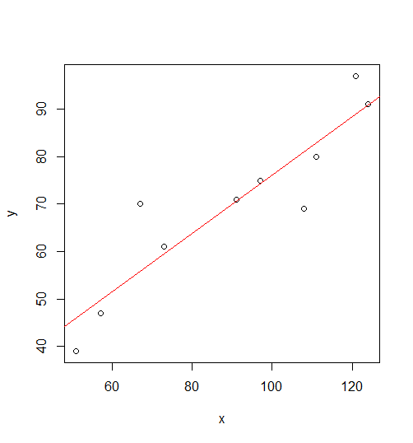

Task 7
Compute the two equations of the regression lines for the following data:
A panel of judges A and B graded seven debaters and independently awarded the following marks:
Marks by A: 40 34 28 30 44 38 31
Marks by B: 32 39 26 30 38 34 28
An eighth debater was awarded 36, marks by Judge A while Judge B was not present.
If Judge B was also present, how many marks would you expect him to award to eighth debater assuming same degree of relationship exists in judgment?

R-CODE:

x=c(40,34,28,30,44,38,31)
y=c(32,39,26,30,38,34,28)
regyx=lm(y~x)
regyx
regxy=lm(x~y)
regxy

#When x=36
y=11.8703+0.5874*36
y

OUTPUT:

>regyx
Call:
lm(formula = y ~ x)

Coefficients:
(Intercept) x
11.8703 0.5874

The Regression Line of y on x is 0.5874x + 11.8703

>regxy
Call:
lm(formula = x ~ y)

Coefficients:
(Intercept) y
7.6968 0.8419

The Regression Line of x on y is 0.8419y + 7.6968

> y
[1] 33.0167

Task 8
The following table gives the ages and blood pressure of 10 men.
Age (X): 56 42 36 47 49 42 60 72 63 55
Blood Pressure(Y): 147 125 118 128 145 140 155 160 149 150
Find (i) The two regression line equations.
(ii) Estimate the blood pressure of men whose age is 45 years
(iii) Estimate the age of men whose blood pressure is 172.
(iv) Construct the regression plot of blood pressure on age.

R-CODE:

x=c(56,42,36,47,49,42,60,72,63,55)
y=c(147,125,118,128,145,140,155,160,149,150)
regyx=lm(y~x)
regyx
regxy=lm(x~y)
regxy

#When x=45
y=83.76+1.11*45
y

#When y=172
x=-49.2958+0.7163*172
x

OUTPUT:

>regyx
Call:
lm(formula = y ~ x)

Coefficients:
(Intercept) x
83.76 1.11

The Regression Line of y on x is 1.11x + 83.76

>regxy
Call:
lm(formula = x ~ y)

Coefficients:
(Intercept) y
-49.2958 0.7163

The Regression Line of x on y is 0.7163y – 49.2958

>y
[1] 133.71

> x
[1] 73.9078

plot(x,y,xlab="Age",ylab="Blood Pressure",xlim=c(30,100),ylim=c(100,200),main="Regression")
abline(regyx,col="green")

Plot:

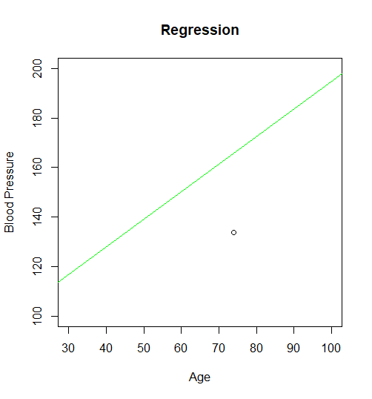

STEP 3: PRACTICE/TESTING
- Define correlation.
Correlation is a statistic that measures the degree to which two variables move in relation to each other.

- What are the various methods of studying correlation?

      - Scatter Diagram Method
      - Karl Pearson’s Correlation Coefficient
      - Spearman’s Rank Correlation Coefficient

- Explain scatter diagram.

The scatter diagram is a technique used to examine the relationship between both the axis (X and Y) with one variable. In the graph, if the variables are correlated, the point will drop along a curve or line. A scatter diagram or scatter plot, is used to give an idea idea of the nature of relationship.

- Define regression.
Regression is the measure of the average relationship between two or more variables in terms of the original units of the data. It provides a mechanism for predicting or forecasting.

- What are regression lines? Write their equations.
If two variables X and Y are correlated, we see that the scatter diagram will be more or less concentrated around a curve, called the curve of regression. If this curve is a straight line, then it is called line of regression.
The equation of the line of regression of Y on X is
𝑦−𝑦̅=byx(𝑥−𝑥̅)
The equation of the line of regression of X on Y is
𝑥−𝑥̅=bxy(𝑦−𝑦̅)
- Mention some properties of regression lines.
Regression coefficients values remain the same. Since shifting of origin takes place because of the change of scale.
If there are two lines of regression. Both of these lines intersect at a specific point [x’, y’]. Variables x and y are taken into consideration. According to the property, the intersection of both the lines of regression i.e. y on x and y is [x’, y’]. This is the solution for both of the equations of variables x and y.

